HOW TO CREATE USERS ON AN ACTIVE DIRECTORY

STEPS TO CREATING USERS ON AN ACTIVE DIRECTORY

- Open Server Manager Dashboard
- Click on Tools,
- Click on Active Directory Users and Computers
- Click on Server DNS name e.g test.dns
- Click on Users
- Click on the icon (create a new user in the current container) or right click in side the container, point to New and click on User
- Fill all option, click next
- set password and other security setting, click next
- verify your settings and click Finish

STEP 1
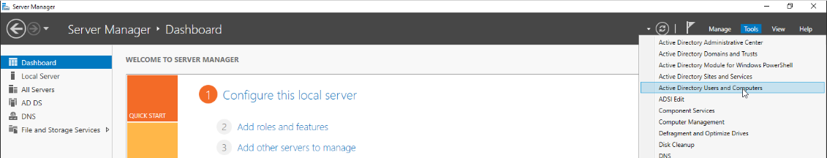
STEP 2
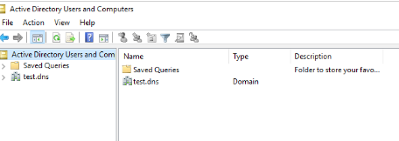
STEP 3

STEP 4

STEP 5
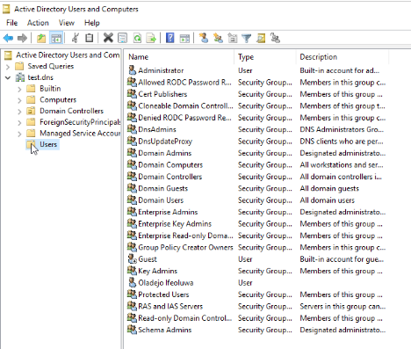

STEP 6
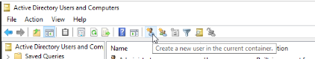

STEP 6
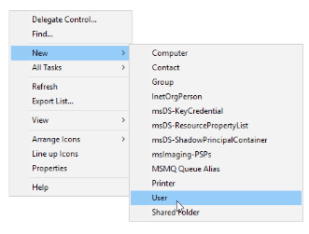

STEP 7
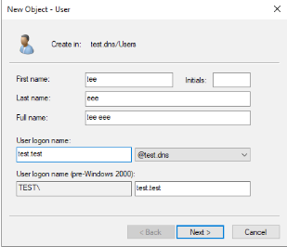

STEP 8 STEP 9
